Title

Starrock – The Game
For Windows
Ship Date: TBA

Game Outline

Game Story:
The player chooses one of several spaceships with which he tries to survive as long as possible. To survive he has to dodge asteroids, shoot enemy ships and loot enemy ships and wreckages. Furthermore he has to keep an eye on his valueable ressources.

Elevator pitch:
Enhanced Asteroids with much more options and features.
Character

The player chooses a spaceship which will then be considered his character. Each ship has a specific amount of the following ressources:
- Health
- Mass
- Energy
- Fuel
- Shield capacity
When health or fuelbar hit zero the session is over. Higher mass combined with same engine power loweres the acceleration the ship has. Energy is needed in order to use weapons and the shield generator. Fuel is necessary to move the ship. The Shield prevents damage from lasers and lowers the amount of damage taken from other weapons.
Gameplay

The player controls his spaceship in a survival-like scenario, trying to survive as long as possible while scavenging wreckages, avoiding asteroids and fighting enemy ships which try to scavenge wreckages before the player or try to destroy him.

Before a session, the player chooses one out of several ships. Each ship provides different boni such as a higher mass,.
A session lasts until the player is destroyed or runs out of fuel. That means, that there is no win condition, since with elapsing session time the environment will be more difficult, e.g. more enemies or asteroids spawn or reducing spawn times. This increases until the player has no chance to survive.

After a session the player will be rewarded with points through the scavenged wreckages or destroyed entities, which can be used to purchase modules for the next session or unlock new ships.
Purchased modules last only for one session, since the ship will be destroyed (when running out of fuel, sooner or later the ship will also be destroyed by asteroids), so they have to be purchased again in the next session.
Through scavenging wreckages, the player can find new module blueprints, recharge energy, replenish fuel or repair damage.

The points obtained in a session will be stored in an online database, so that players can see the results of other players in a ranking.
Game World

A game session takes place in a plane in outer space, which is restricted by a boundary. The player can not get out of that boundary, but asteroids can travel through. Enemy spaceships and wreckages will spawn only inside the boundary.

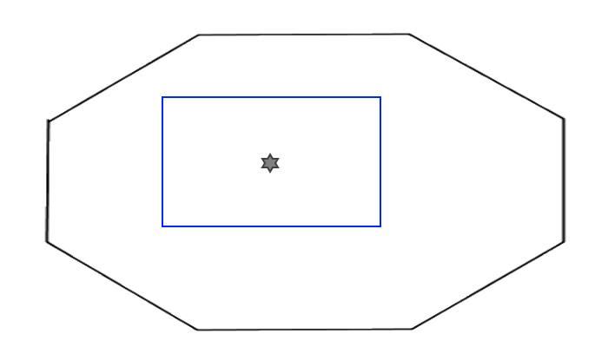
Image: Shape of the map

The map is an octagon. The blue square represents the part of the map that is visible in the minimap. The star represents the ship.
Game experience

Power up your ship, unlock new bigger ships, defeat mighty enemys (including random boss fights), dodge giant asteroids and become the number one player on the leaderboard.
Gameplay mechanics

Mechanics:
Wreckages can be scavenged by flying through them and holding the scavenge button for a second. While pressing the button a guage will appear which states the scavenging progress. If the player releases the button before the process is finished, the progress will be resetted. They provide at least one of the following effects:
- Fuel
- Energy
- Repair
- Module blueprints
- Extra currency

Hazard:
Asteroids can hit the player and destroy it. Enemy ships will also be damaged by asteroids.

Collectibles:
The player will be rewarded with points by destroying asteroids and ships or by scavenging wreckages.

Economy:
After a session the player will be rewarded with a currency, which can be used to buy modules or new ships for further sessions.

AI:
TODO: Swarms of ships(-> Flocking (Craig Reynolds))/few ships with good pathfinding
Pros swarms: not neccesarily good pathfinding & lots of harvestable ships
Tries to approach the player. Might change its behaviour when it is in a certain distance to the player. (-> State machine).

Controls
Keyboard-only and Game Controller.

Keyboard:
WASD – Movement
J – Primary Weapon
L – Secondary Weapon
Space – Scavenge
Left Alt – Show session stats

Game Controller:
Left Stick – Turning
Right Trigger – Accelerate
Left Trigger – Decelerate
Right Bumper – Primary Weapon
Left Bumper – Secondary Weapon
A – Scavenge
Back – Show session stats

Action Costs

Energy
Every shot of a weapon costs energy. The cost is determined by the weapon itself.

Fuel
Fuel cost when accelerating is calculated by the ships' mass, engine power.
Rotating costs less fuel than accelerating. Decelerating does not cost any fuel. While floating, no fuel is consumed.

Collision
Collisions will result in a physical responses like force or impact and in both entities being damaged. The damaged calculated depends on the masses and the velocities of the entities.
When damaged, the hull structure of the entities are reduced. If the hull structure hits 0, the entity is destroyed. Is one of the entities a laser and the other has a shield, the shield will be damaged before reducing the hull structure. When one of the entities is a mine or a missile, the shield will only reduce a part of the damage, resulting in damage both to the shield and the hull structure.

Asteroids will be destroyed when they hit a player (in higher difficulty they could split into smaller asteroids).

Minimap
The minimap shows the location of other entities close to the player. What will be shown depends on the difficulty level:
Easy – shows Asteroids, enemy ships and wreckages
Medium – shows enemy ships and wreckages
Hard – shows wreckages
Lost – doesn't show anything
Difficulty Level
While choosing a ship, the player can also choose a difficulty level out of four levels:
- Easy
- Medium
- Hard
- Lost

The higher the level, the more points are rewarded, but on the same page, the spawn count and spawn times also decrease.

Wreckages
In the beginning of a session, a set amount of wreckages are placed all over the game boundaries.
When enemy ships are destroyed, they turn into wreckages which can be scavenged.
Asteroids do not leave behind wreckages.

Engines
Engines emit visible particles, which move into the opposite direction of the engine's direction with a random distortion.
Class Design

Enemies

From time to time enemy spaceships will come from other dimensions through wormholes into the boundary of the game space. These enemy ships are divided into four different classes:

- Destroyer
The destroyer class is equipped with weapons and tries to shoot the player ship

- Kamikaze
The kamikaze class has no weapons but will try to ram the player ship

- Scavenger
The scavenger class will focus to avoid the player and scavenge wreckages

- Dreadnaught
The dreadnaught class is like a boss, equipped with high damage weapons, much more structure, multiple times bigger than your standard enemy and will try to destroy the player

The enemy class only describes the behavior of the ship. In a class there can be several different types of ships. The equipped modules of an enemy will be determined on spawn.

Each destroyed enemy rewards points and currency. The amount depends on the enemy class and type.
Multiplayer and bonus materials

Multiple player can connect via P2P to play against each other, trying to survive longer than the others or to play in a cooperative mode, where more enemy ships will spawn than in single player mode.
Monetization

A player can buy exclusive ships in a store.

